1/20/2026
Portfolio Document – Brute force attack attempt

Kali VM using crackmapexec smb 10.0.0.16 command to run a brute force attack on target
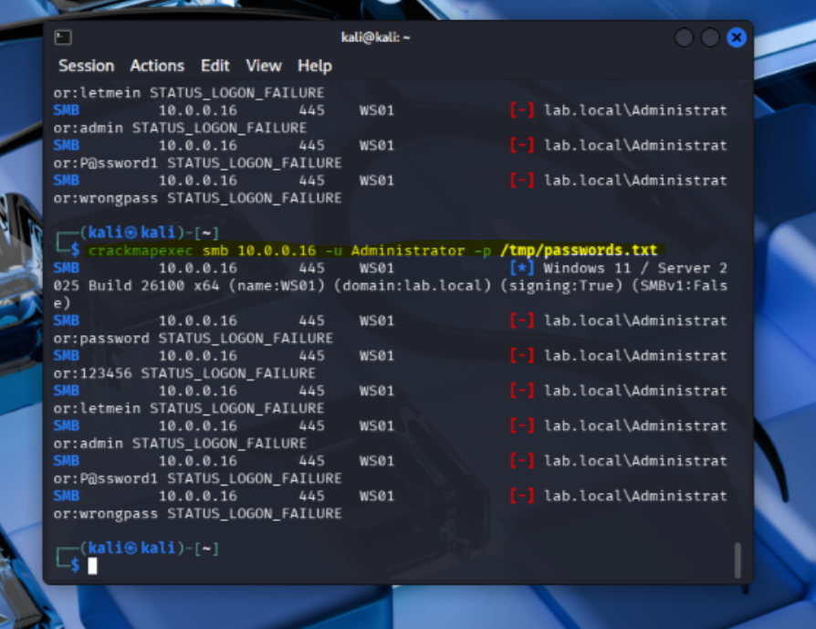
Screenshot of the MITRE ATT&CK showing "Initial Access: 13”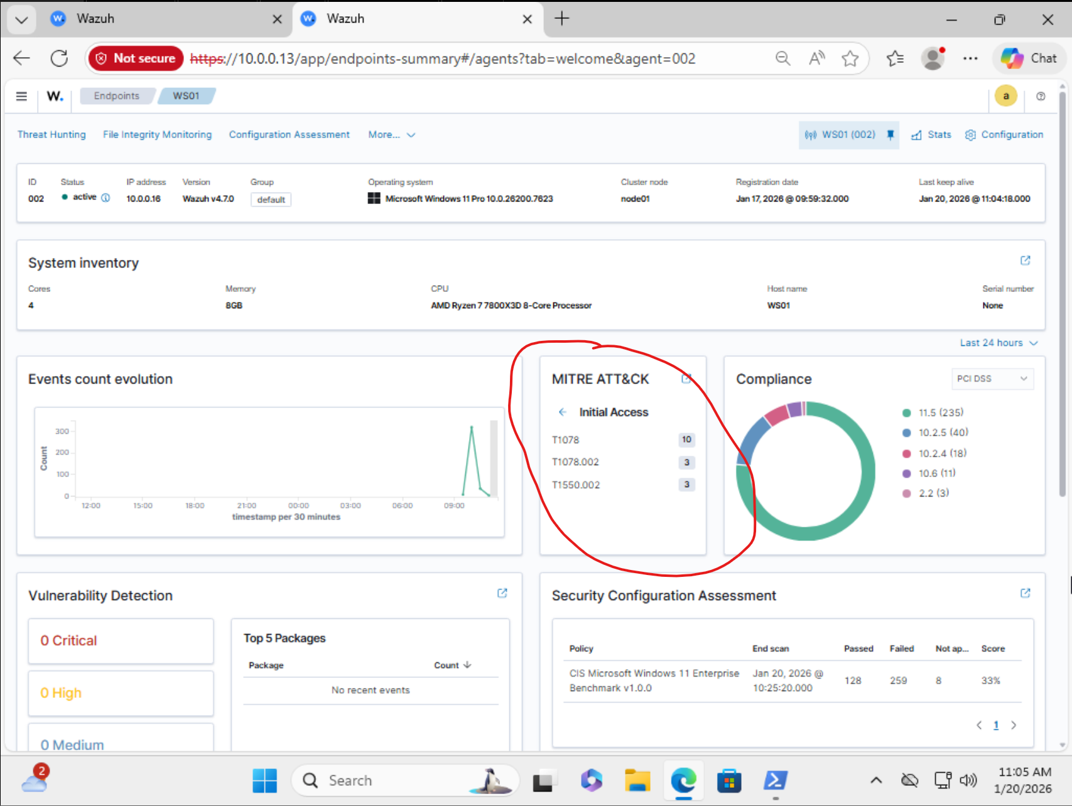

Screenshot of the filtered 4625 events list
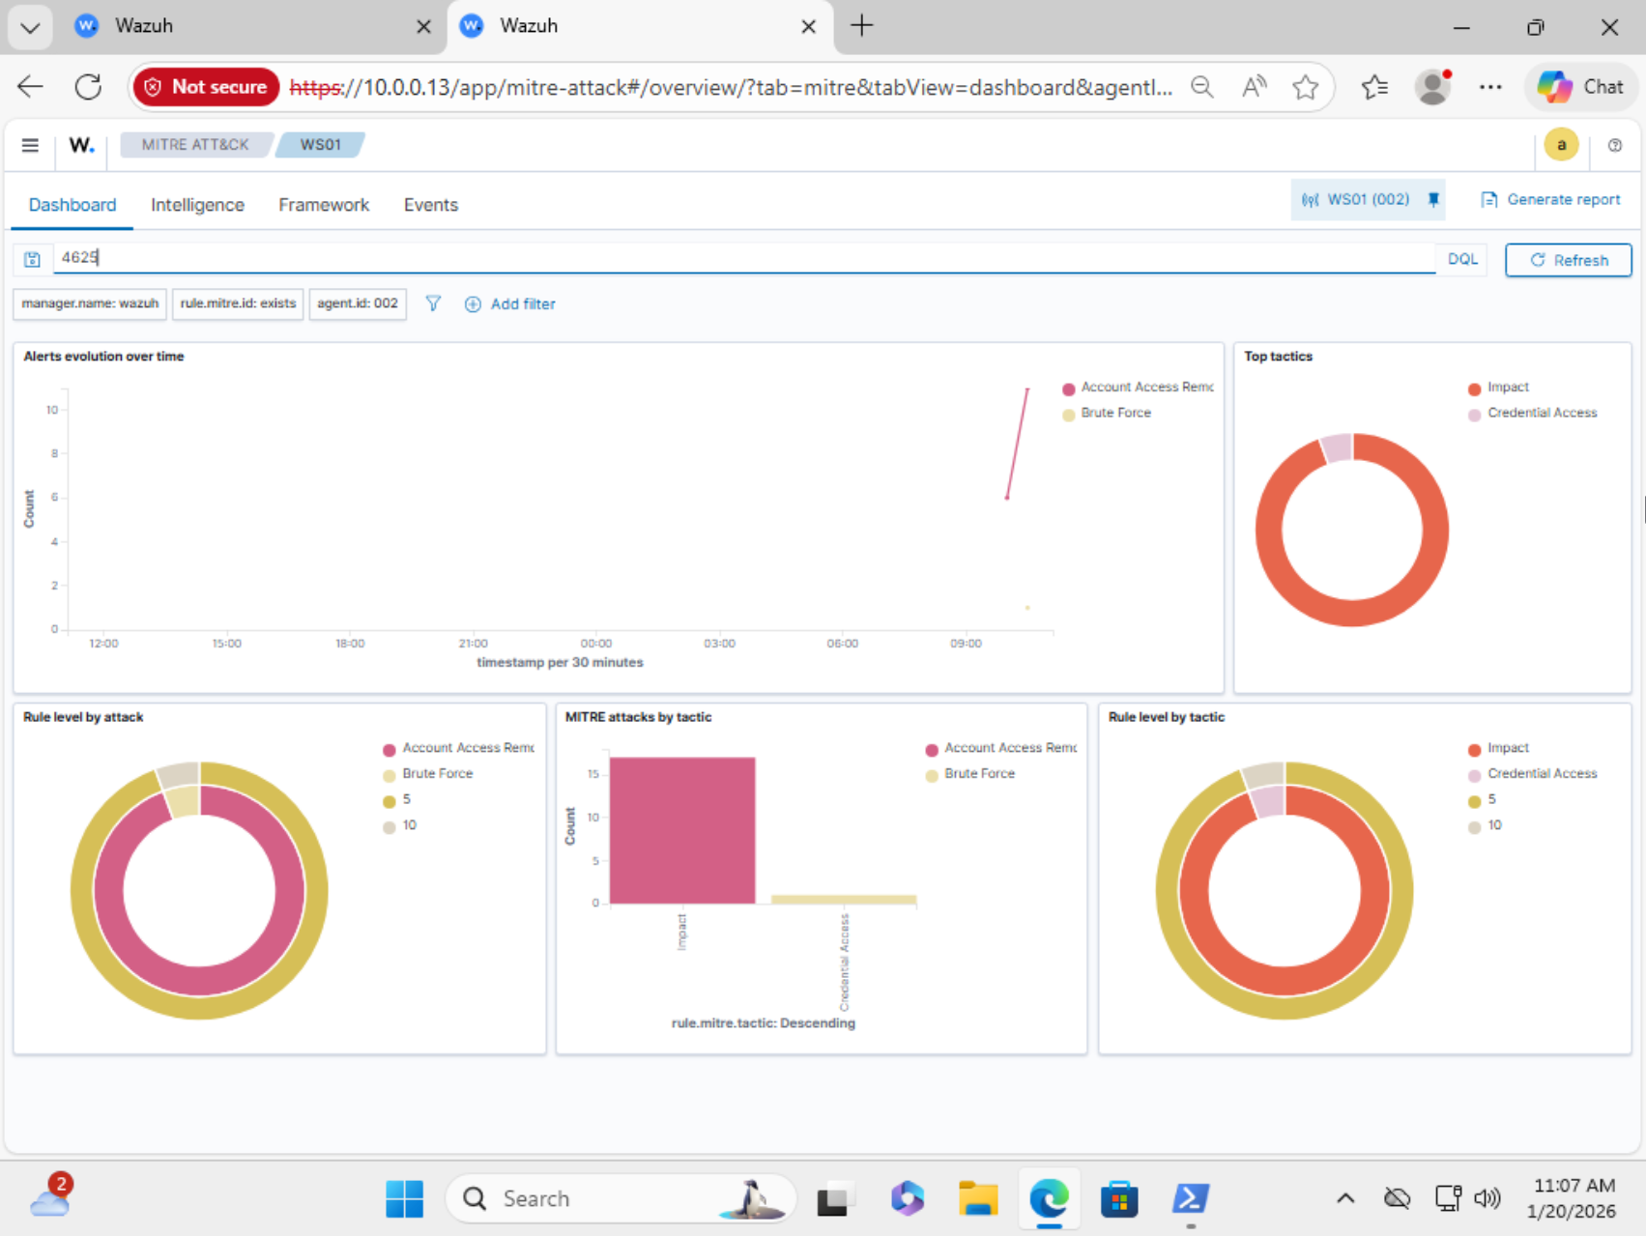

Event List showing failed logon attempts
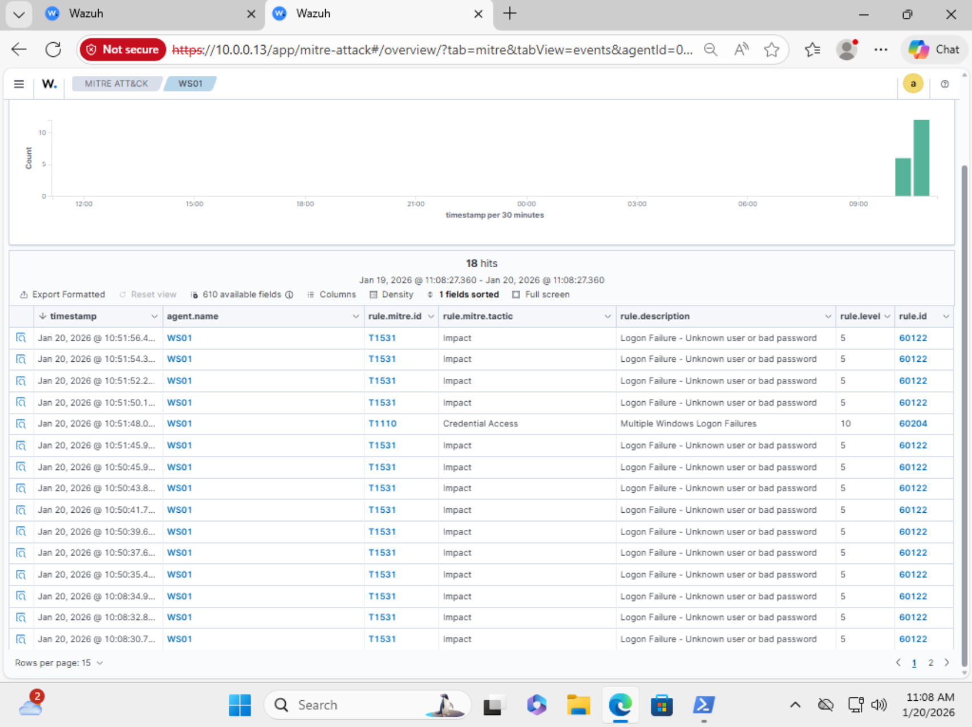

Source attacker IP address for specific Failed Logon Attempt event
